 | LDCW6123 - FUNDAMENTALS OF DIGITAL COMPETENCE FOR PROGRAMMER
 | Group Project
 | Trimester 2620
 | Due date: 02 OCT 2026 (Friday) | 11.59pm | W7

General information:

Group formation | Group members shall not exceed 6 students per group and must be from the same class section. Register the team members in online group registration form.
Assessment | This group assignment contributes 40% to the total coursework marks.
Submission requirements | Submission | Submission by the group leader only.  - Project report (pdf) containing: -  - Coversheet  - Members Declaration  - Table of content (TOC):  - Part 1- Innovation Life Cycle Poster  - Part 2 – Interactive system (C++)  - Recorded video presentation (OneDrive link)  - Recorded Video presentation in mpeg/mp4/mov format. Duration Max: 18 min  _____________________________________________  - Only group leaders will make the submission. You will follow your respective tutor submission procedure.  - Name your report as;  Ldcw6123_project_section_leadername (student id).pdf
Submission requirements | Cover page | Please use the attached coversheet.
Submission requirements | Group member’s declaration form | Please use the attached form.
Submission requirements | Assessment rubrics | Included for reference. You do not need to include the rubrics into the report.

Mapping of assignment learning outcomes to subject learning outcomes:

Project Learning Outcomes  Upon completion of this project, students should be able to: |  | Course Learning Outcomes  Upon completion of this subject, students should be able to:
1. | Develop a poster and program showcasing the technology from an innovation lifecycle. | CLO3: Build a basic interactive program with digital content.

Project Title: Innovation Technology Life Cycle Poster and Interactive Program
Group member: Min 4 – Max 6 student per group.

Instructions:
students will work together to design and develop part 1 and 2 of the project. Each group member will collaborate online to complete the projects.
1. (INNOVATION TECHNOLOGY LIFE CYCLE POSTER) – 20%
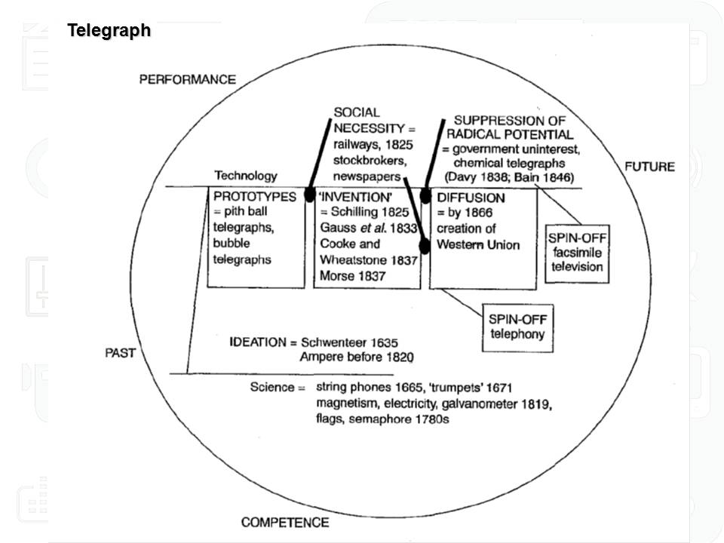
Choose a specific scientific or technological innovation and trace the development life cycle on a poster. Your chosen technology may be something local (like a Aerodyne Drones - Malaysian global leader in drone-based solutions for agriculture, inspection, and security) or international (e.g.: Netflix, TikTok Social Commerce). This poster should be presented as either an A3 poster made into a PDF, or as PowerPoint slides. The “innovation model” you choose will depend on the innovation you want to trace. If the innovation was “disruptive” you might choose Clayton Christensen’s model. If the innovation met a pre-existing need in society (e.g., poster for the telegraph) you might choose Brian Winston’s model .There is a template for both model provided along with this project assignment on eBwise. Please check with your lecturer if you are unsure about the innovation/invention you have chosen .
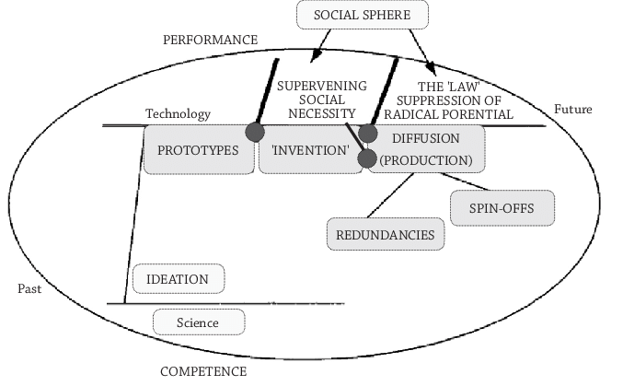
Depending on the innovation you choose, and whether or not that product met a pre-existing social need or alternatively created/disrupted a market, you may choose one of the following models to apply. The steps to identify are different in each case: if you choose Christensen’s model you will also need to show which market was ‘disrupted’. If you choose Winston’s model you will need to identify the social needs (“supervening social necessities”) that aided invention and adoption.
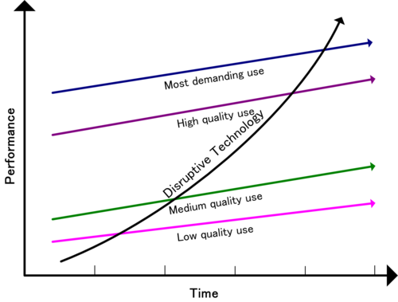

Clayton Christenson’s Disruptive cycle model Brian Winston’s cycle model –
- Innovation technology Innovation technology

Once you have identified the different steps in the development of your innovation, you can create the flow chart in Canva/Adobe software or in PowerPoint, or in any software program you have at hand. You will not be marked on your “design” abilities, but the flow of the innovation should be clear. You will be assessed on your ability to identify the correct steps in the innovation life cycle, your understanding of the history of your specific innovation, and the historical accuracy of those steps. Make sure you choose an innovation where you can determine the different steps. Include this poster in your PDF report submission.
Criteria:
(1) A clear schematic representation of the innovation life cycle
(2) Evidence of research – make your steps historically accurate
(3) Evidence that you understand the “innovation life cycle” you have chosen
(4) Evidence that you understand its social impact or the social necessity
(5) Place referencing (APA Style)
2. (C++ PROGRAMMING) – 20%
After completing Part 1, where you researched and discussed your chosen technology using either the Disruptive Innovation or Winston’s cycle model, you will now proceed to step 2 by designing a simple interactive program in C++.
General Steps
1. Connect with your chosen technology.
- If, your chosen technology is Netflix, it should be used as inspiration for your C++ program.

- Decide the Purpose of Your Program
- Think of a real-world feature or function relevant to your technology. Examples:
- Netflix: Movie finder or recommendation based on user preference.
- Ride-hailing: Simple fare calculator.
- E-commerce: Product suggestion or shopping cart summary.

- Outline Inputs and Outputs
- Plan what the user will enter (genre, distance, product type) and what the program will display (suggestion, calculation, confirmation).

- Design Logic
- Use if/else or switch statements to process user choices and produce results.

- Document Development Progress with Git Log
- As part of your submission, include a trace of your project’s development history using Git.
- Make regular commits at each stage (e.g., after outlining inputs/outputs, designing logic, coding features).
- At the end, run `git log --online --graph` and include a screenshot or text output in your submission.

Example:
If you chose Netflix as a disruptive innovation model:

Title program (C++): Movie Recommendation Assistant
Inputs: Movie genre preference
Outputs: A suggested movie title and a brief description

Highlight:
In 1 PDF:
- Coversheet and member declaration
- Toc
- Part 1 : Innovation Lifecycle Poster
- Poster references
- Part 2: Include a screenshot of the codes and output and gitlog history
- A link to the source code and GitLog
- Recorded group presentation video link.

Reminders:

Plagiarism
- Plagiarism is a serious offence.
- Plagiarism includes the following behaviors (but not limited to):
  - copy another student’s work.
  - fail to properly cite other people’s work or give proper credit to the original source.
  - using photos, illustrations or online materials downloaded from websites without permission or consent of the original owner of the materials.
  - hire or ask another individual to complete the assignment for you.
  - copy too many words or ideas from one or two sources, that makes up a significant portion of your work, even with proper citations.
- The lecturer has the right not to accept submission of plagiarized or duplicated work.

Group work
- Each group member must actively participate in the completion of the assignment. Free riding is unethical and extremely unfair to fellow group members. Free riders will be awarded zero mark.
- Should any member be found not contributing to the assignment, the lecturer has the right to change the specific group’s marks to individual marks.
- Each group member is expected to keep the contact numbers and e-mail addresses of the other members of the group.
- The group leader has the responsibility to ensure that all group members play a part in the completion of the assignment. The group leader is also responsible for ensuring that all members’ names are written on the final submission.
- It is the responsibility of each group member to ensure that the final submission is complete and of an acceptable standard. Should any errors or omissions occur in the final submission, each group member is held accountable for negligence – in other words, failure to perform their responsibilities as expected.

Late submissions
- Late submissions : Exceptions may be made for late submissions due to serious and valid circumstances (e.g., illness or family emergency), provided appropriate supporting evidence is submitted.

MARKING RUBRIC
Marking Method: | Each criterion is graded on a 1–5 scale. The score is then converted proportionally based on the maximum marks allocated for that criterion.
Conversion Formula: | 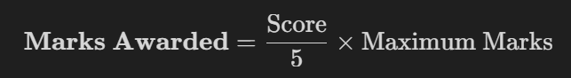
MARKING RUBRIC A
Part 1: Innovation Technology Life Cycle Poster (40 marks)

Criteria | 5  Excellent | 4  Good | 3  Satisfactory | 2  Weak | 1  Very Weak | Max  Marks | Marks awarded
Research & Background | Comprehensive explanation of technology, highly accurate historical timeline, multiple credible sources used. | Clear explanation, mostly accurate history, sufficient supporting sources. | Basic explanation, some inaccuracies, limited research evidence. | Incomplete explanation, unclear or incorrect history. | Very minimal or incorrect content, no evidence of research. | 10
Model Explanation & Application | Model clearly explained that all stages accurately applied to the chosen technology with strong justification. | Model explained well that most stages correctly applied. | Basic explanation, partial application of model. | Weak understanding, incorrect or unclear application. | Model not explained or wrongly applied. | 12
Mapping & Impact Analysis | Logical and well-structured flow, strong analysis of impact/disruption with relevant examples. | Clear flow, good discussion of impact. | Basic flow, limited impact discussion. | Poor flow, unclear or weak analysis. | No clear mapping, no impact discussion. | 10
Critical Thinking & Clarity | Insightful analysis, original ideas, strong understanding. | Some analysis shows understanding. | Limited insight, mostly descriptive. | Minimal thinking, superficial discussion. | No critical thinking shown. | 4
Clarity & Organization | Very clear, well-structured, easy to follow. | Generally clear with minor issues. | Some unclear sections. | Poor organization. | Very confusing presentation. | 4
TOTAL |  |  |  |  |  | /40

MARKING RUBRIC B
Part 2: Interactive C++ Program (40 marks)

Criteria | 5  Excellent | 4  Good | 3  Satisfactory | 2  Weak | 1  Very Weak | Max  Marks | Marks awarded
Program Logic & Functionality | Fully functional, correct logic, handles multiple scenarios accurately. | Mostly functional, minor logic issues. | Basic functionality, limited logic. | Many errors, partially working. | Not functioning. | 10
Relevance & Integration | Strong integration with Part 1, meaningful and realistic application. | Good relation to topic. | Some relevance. | Weak connection. | No relation to Part 1. | 10
Code Quality & Style | Clean, well-structured code, meaningful variable names, proper comments. | Mostly clean, some comments. | Basic readability, minimal comments. | Poor structure, unclear naming. | No structure or unreadable code. | 5
User Experience & Testing | Clear instructions, handles errors, tested with multiple cases. | Good usability, minor issues. | Basic usability, limited testing. | Confusing interface, minimal testing. | No testing or usability consideration. | 5
Git log & Development Process  - Commit quality | Frequent commits, clear, meaningful messages. | Regular commits, mostly meaningful. | Some commits, basic messages. | Few commits, unclear messages. | No Git usage. | 5
Git log & Development Process  - Git Log Presentation | Clear, well-presented log showing development progress. | Mostly clear log. | Basic log shown. | Incomplete log | No log included. | 5
TOTAL |  |  |  |  |  | /40

MARKING RUBRIC C
Video recording presentation and requirements/compliance (20 marks)

Criteria | 5  Excellent | 4  Good | 3  Satisfactory | 2  Weak | 1  Very Weak | Max  Marks | Marks awarded
Content Coverage & Explanation | Clear, complete explanation, strong understanding; effective demo. | Good explanation, minor gaps. | Basic explanation. | Incomplete explanation. | Very unclear or missing content. | 10
Compliance & Documentation | Follows all submission instructions, includes all required documentation. | Minor missing elements. | Some missing components. | Many missing requirements. | Not compliant. | 5
Originality & Integrity | Highly original, properly cited, no issues. | Mostly original, minor citation issues. | Limited originality. | Significant similarity issues. | Plagiarism detected. | 5
TOTAL |  |  |  |  |  | /20
TOTAL A+B+C |  |  |  |  |  | 100

